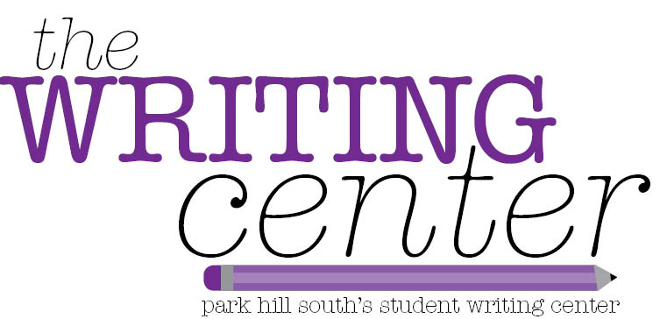
Graphic Organizer – Narrative Writing
Bold Beginning

Hook  The hook captures the readers’ attention. It makes them want to read the rest of the story. | Beginning  Topic Sentence | Details
 | Middle  Topic Sentence | Details
 | Ending  Topic Sentence | Details
Conclusion

